
2024
Carter County
Report to the People

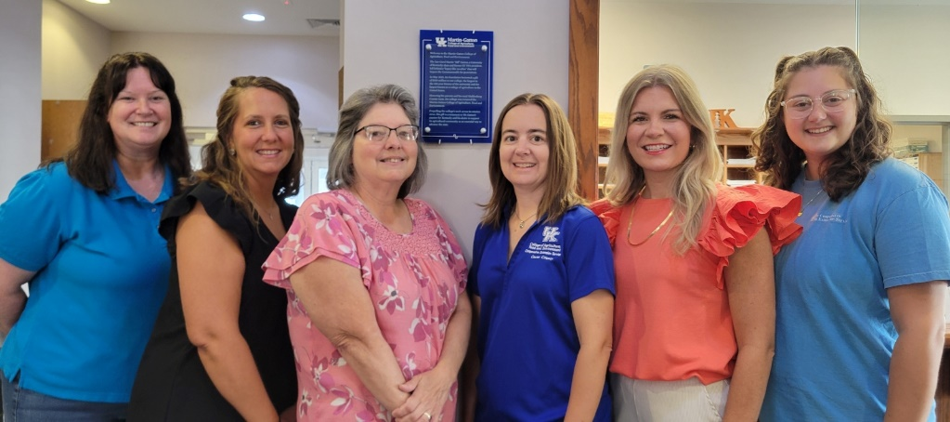

Carter County Extension Office Staff

For More Information, Please Contact us at:
Carter County Extension Office
94 Fairground Drive
Grayson, KY 41143-9520
(606) 474-6686
https://carter.ca.uky.edu Carter County Extension Office

4-H Youth Development
- @ Carter County 4-H

· 4-H School Clubs
· School Enrichment Programs
· Livestock Program
· Summer Day Camps
· 4-H Camp
· Teen Summit
· Teen Conference
· Win with Wood

Family & Consumer Sciences
@ Carter County Extension-Family and Consumer Sciences Education
· Basic Cooking for kids & Adults
· Laugh & Learn Playdates
·Life Skills Across the Lifespan
· Longest Day of Play
· Nutrition & Wellness
∙Extension Homemaker Clubs
∙Financial Management
· Food Preservation & Canner Testing
∙Interagency Coalition

Ag/Natural Resources
@ Carter County Agriculture Extension Service
@CarterCoKYAg

· Livestock Association
· Private Pesticide Applicator Trainings
· Soil Testing
· Hay Testing
· Beekeeper Association
· Farmer’s Market
· Hike & Learn
∙ Field Days & Workshops

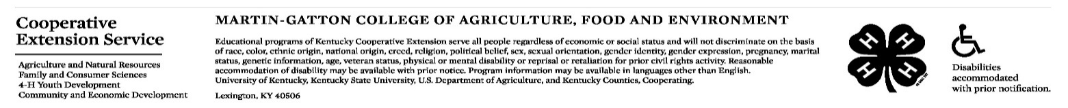

CONTACT:

Carter County Agriculture and Natural

Resources Featured Programs Rebecca Konopka, Agent

Ag/ Natural Resources
rebecca.k@uky.edu

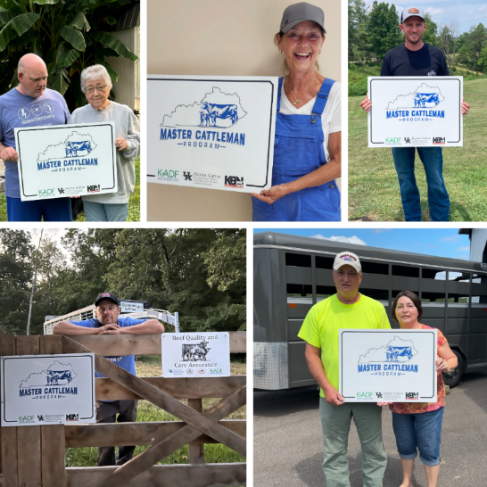
Carter County Agriculture & Natural Resources Featured Programs
Master Cattleman - Kentucky is the largest cattle producing state east of the Mississippi River and the 2022 Census of Agriculture reported that Carter County has over $2.7 million in cattle sales annually. Over six nights in early 2024, Extension specialists delved into a comprehensive range of topics critical to beef production success. To complete the program participants also had to attend a forage session and Beef Quality & Care Assurance.
Over 70 people from four local counties registered for the program, including 10 from Carter County. Six of the Carter County producers completed all the requirements of the program and received a farm sign. Producers reported making the following changes to their operations since attending Master Cattleman: using EPDs when selecting bulls, keeping more accurate calving records, purchasing quality feed, better pasture management, cleaner water in pastures, and streamlining facilities.
Master Cattleman participants show off their signs.

Resources for Using the County’s Shared-Use No-Till Drill – Even though the Soil Conservation District rents out a Great Plains No-Till Drill, many farmers were unfamiliar with the calibration procedures. Since improper calibration leads to poor stands and lost profits the ANR Agent has worked to help farmers effectively use the drill.
A no-till drill clinic educated 100 landowners on seeding equipment. The clinic included seeding tips and tricks, distinguishing features and calibration techniques of each of the six drills on display, and a calibration demonstration of the Great Plains drill. Farmers also received a handbook of UK forage publications.
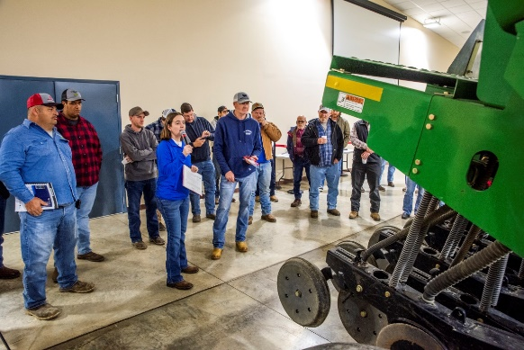
- Evaluations of the night of the clinic showed that producers felt more confident going into planting season. One participant said, “As a newbie to farming (and a young woman), I feel like each piece of equipment was explained in terms that I could understand.” A survey ten months after the clinic showed the following results:
- 83% felt more confident in their ability to calibrate and use the equipment.
- 71% were pleased with their grass stand establishment.
- 81% thought that the use of a no-till drill had improved their productivity.
Rebecca Konopka discusses the steps to calibrate the No-till drill during the clinic.
A video reviewing calibration steps is posted on the Carter ANR webpage and YouTube channel.
Hose clamp pliers and a small digital scale have been placed in the manual box on the drill so that farmers can easily remove the tubes and weigh seed for calibration purposes. Additionally, a complete manual and seed charts were placed in the box.

Additional ANR Programs
- The Little Sandy Beekeepers met monthly with an average attendance of 14 to listen to guest speakers or share ideas with each other so that they can improve their efficiency.
- The Northeast Area Livestock Association met 6 times throughout the year with an average attendance of 52. In addition to a great meal, meetings also feature presentations by University of Kentucky specialists and industry professionals. Topics covered included interpreting hay sample results, calving issues, livestock facilities, equipment maintenance, watering livestock, and understanding seed tags. Three members attended the 2024 Kentucky Cattlemen’s Association Convention.
- Over 50 people placed orders for berry plants and/or apple or pear rootstock to grow their own nutritious fruits.
- Twenty-one farmers earned certifications in Beef Quality Care & Assurance, Small Ruminant Quality Assurance, and/or Private Pesticide Applicator.
- Sixteen vendors were trained to accept Senior & WIC vouchers at the Carter County Farmer’s Market. Over $24,600 was distributed to low-income seniors through the Senior Farmer’s Market and Double Dollars program. Kid’s Day was held at each market with activities for youth and the distribution of over $500 in Kid’s Bucks to be spent at the market. Total 2024 market sales for both the Grayson & Olive Hill locations were $33,365.
- During 2024, participants had the opportunity to hike over 18 miles through the Hike & Learn program which included 7-day hikes and a weekend trip to New River Gorge National Park.
- The Carter & Elliott County Ag Agents worked together to encourage Gardening in Small Spaces with a garden tour at Angie & Eddie Fultz’s.
- Over 170 people attended the annual Farm & Family Field Day at Rick & Sherri Rayburn’s. The field day featured discussions on small ruminant herd health, hay production, watering systems, and NRCS opportunities. Additionally, 16 local businesses and agriculture organizations were on hand to meet and greet attendees.
- A regional Beginning & Small Farmer School provided insight and resources for 77 clientele that are new to farming operations.
- Thirty-one ladies and 23 students from the East Carter High School Community Workforce Transition program made fresh evergreen swags during one of three workshops.

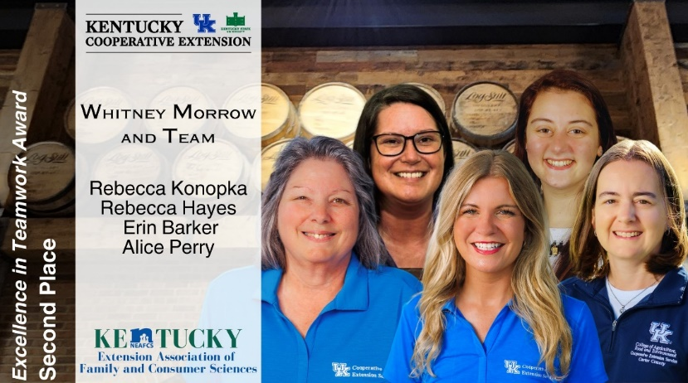


The Excellence in Teamwork Award promotes and recognizes outstanding Extension programs conducted by multi-disciplinary teams that demonstrate effective performance and significant results.
The Carter County "Make & Take Program" empowered youth and adults to learn valuable skills, embrace teamwork, and enhance creativity through multiple hands-on workshops presented by the local Cooperative Extension Service team including FCS, Agriculture and Natural Resources and 4-H Youth Development. The Carter County office team received 2nd place in the state and nation and 1st place in the Southern Region.

CONTACT:
Carter County 4-H

Rebecca Hayes, Agent

4-H Youth Development

rebecca.hayes@uky.edu

Carter County 4-H Council hosted 2 door-hanging workshops, and one flower bulb fundraiser, and sent out about 100 sponsorship letters to community businesses. Through these efforts, they raised about $9,000 for 4-H Camp Scholarships.
The median Carter County household income is $47,000. 23.9% of the population for whom poverty status is determined in Carter County, KY (6.2k out of 25.9k people) live below the poverty line. 23.4% of the children are living in poverty in Carter County. (https://datausa.io/profile/geo/carter-county-ky)
The impact of this $9,000 is undeniable. This scholarship money is more than just a ticket to summer fun. They're an investment in the future leaders of Carter County. It translates to roughly 16 campers who can foster crucial life skills, leadership development, and a deep appreciation for the natural world.
The Carter County 4-H Council expresses their deepest gratitude to everyone involved. This incredible accomplishment wouldn't have been possible without the unwavering support of businesses, community members, and generous donors. Thanks to their efforts, more Carter County youth will have the chance to experience the magic of 4-H Camp, making a lasting impact on their lives and the future of their community.

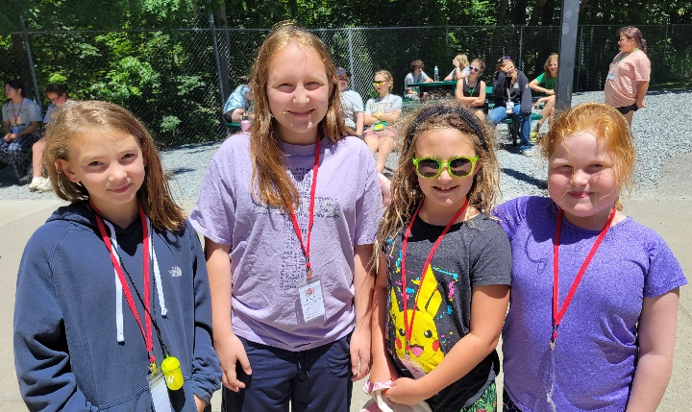

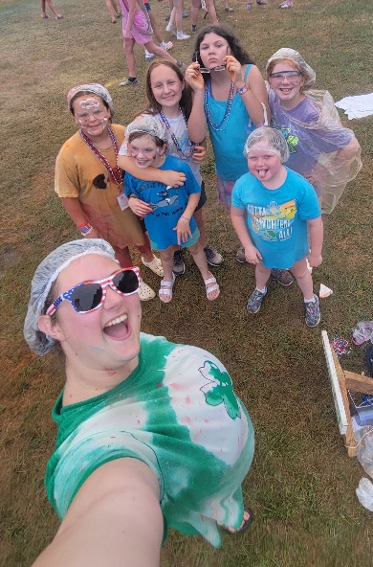
Having fun at recreation camp!

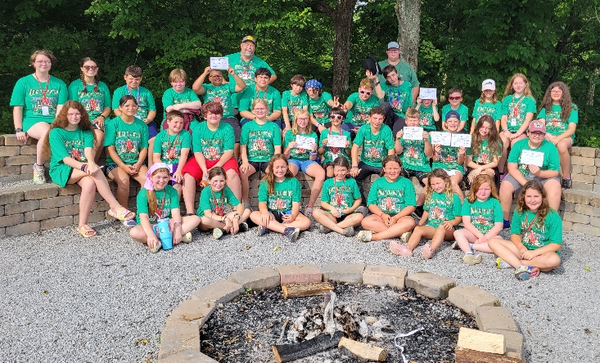
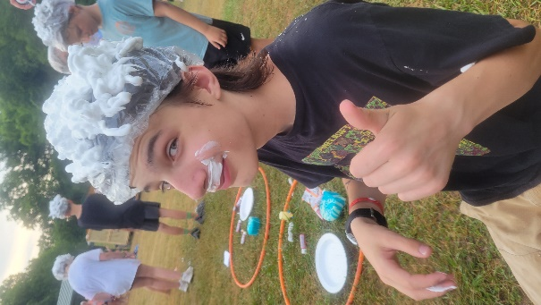
Cheeto Head Messy Game!
Fun with all the mess from messy games!

The Carter County 4-H Camp participants and volunteers.
Contact:
Whitney Morrow, Agent
Family & Consumer Sciences
Whitney.morrow@uky.edu

Family & Consumer Sciences

Based on the Cooperative Extension Community Needs Assessment, having access to nutritious foods and food security is the number one concern in Carter County. Teaching residents to prepare their own food using limited ingredients can help them become more self-sufficient, potentially reducing grocery costs, and increasing food security, especially those on limited resources. Sourdough bread has gained popularity in recent years through social media and with the rise of grocery costs. The Carter County Family and Consumer Sciences agent received numerous requests for a sourdough workshop. Four classes were offered to empower residents to cultivate valuable skills, promote self-sufficiency, and foster a connection to culinary traditions.
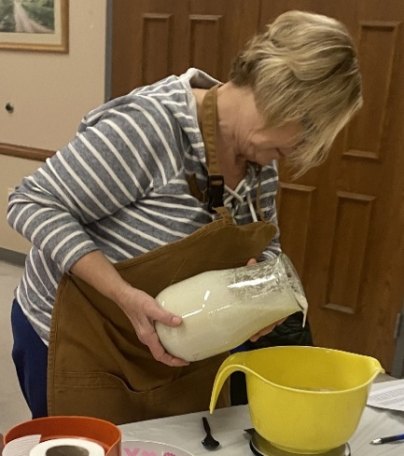
One hundred and nineteen participants, many who were new to extension programs, gained hands-on experience with the sourdough bread-making process, including starter creation, dough manipulation, and baking techniques. They also learned the health benefits of sourdough, measuring skills using a scale, and the science behind baking bread. This newfound knowledge fostered a sense of accomplishment and allowed participants to bake delicious, healthy bread at home. Sourdough baking is a time-honored tradition with a rich history. The workshop reconnected participants to this heritage and allowed them to appreciate the artistry and patience involved in creating a quality loaf. The workshop fostered a sense of community by bringing people together to learn a shared skill.
Participant pouring starter.

The target audience was all Carter County residents. People of all ages, genders, and economic statuses gathered, including multiple families with three generations or more. The program got so much social media attention that it expanded to multiple surrounding counties.
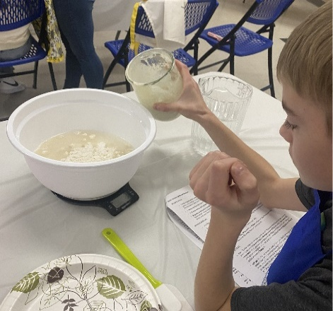
The workshop was evaluated by hands on demonstration and 100% of the participants made their own dough and loaf of bread. They emailed pictures of their finished loaves to the instructor. Participants shared their experiences and successes, creating a network of sourdough enthusiasts within Carter County. At least 5 participants went back to their communities, families, and Homemaker clubs and taught others the skill. The workshops offered a valuable learning experience that extends beyond just baking bread. It promoted self-sufficiency, cultural connection, and community engagement, all of which contributed to the well-being of Carter County residents.
Youth participant demonstrating new skills.

The success of this program identified the teaching kitchen that currently in the process of being completed in the new addition to the Carter County Extension Campus. Upon its completion a baking series is planned to help residents learn more skills to feed their family at a lower cost.


The Carter County Extension Service has expanded with a new building this year. This new building will provide us a new meeting room and classroom space for extension programs.

UK Extension Hosts Morocco Group to Learn New Ideas for Improving Communities Back Home
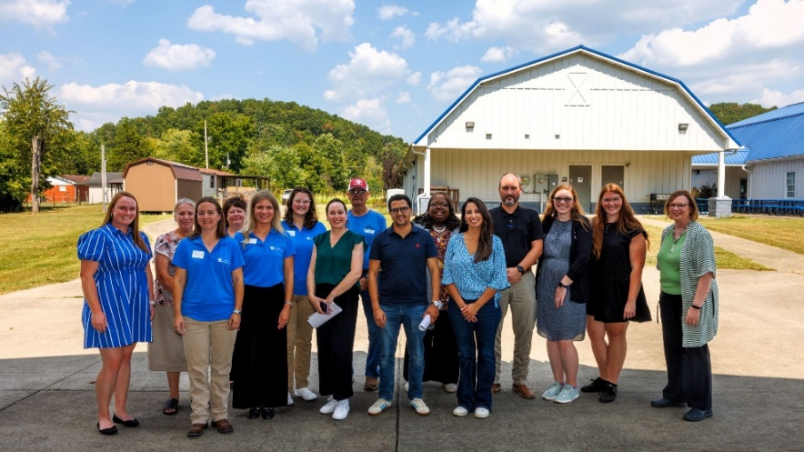
The University of Kentucky Cooperative Extension Service at the Martin-Gatton College of Agriculture, Food and Environment recently hosted a group of agricultural professionals from Morocco. This group’s goal in visiting Lexington was to understand how UK Cooperative Extension serves all 120 counties in Kentucky and use it as a roadmap to serve more communities in Morocco.
The two-day visit included several interactive workshops and presentations, along with site tours at the Carter County Extension Office and the UK Horticulture Research Farm.
During the first day at the Carter County extension office, participants learned more about extension efforts like the Kentucky 4-H youth program from local 4-H’ers.
Rebecca Konopka, extension agent for Carter County at Martin-Gatton CAFE, demonstrated hay testing to the group.
“Two of the top agriculture commodities in Carter County include forages and cattle,” Konopka said. “For the past several years, Carter County has collected the most samples for the East Kentucky Hay Contest. Local producers understand the value of knowing the nutrient analysis, leading to better management decisions to reduce costs and/or increase profits. I’m glad that the group was able to learn how valuable extension is for local producers.”

