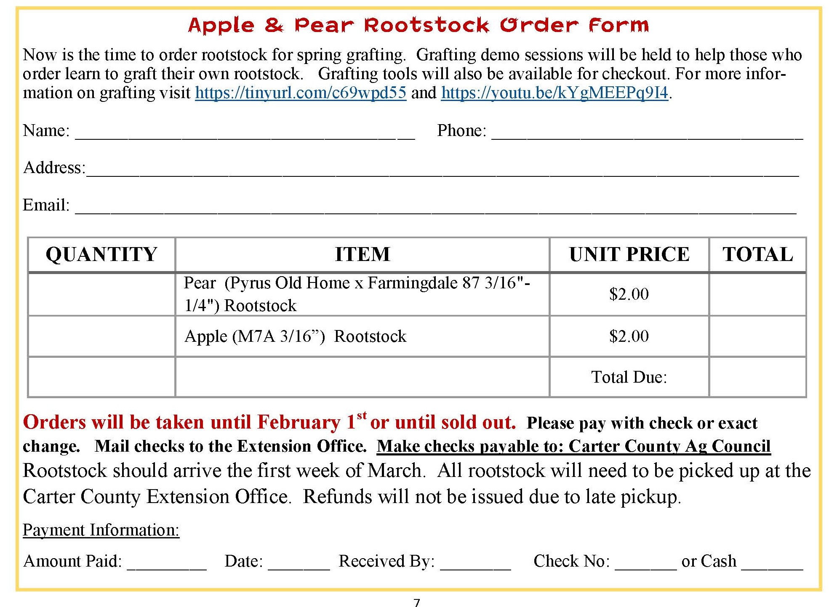

Mail to: Carter County Extension Office

94 Fairground Drive

Grayson, KY 41143