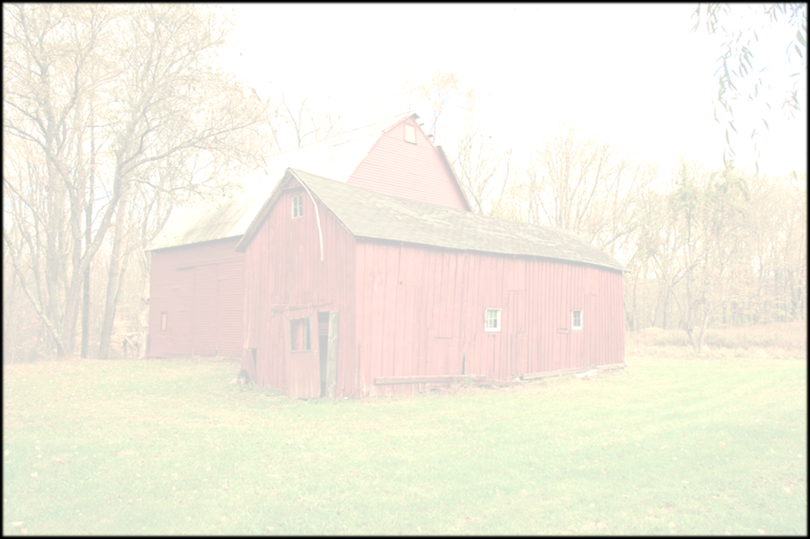
MONEY FOR FARM
IMPROVEMENTS AVAILABLE…
COUNTY AGRICULTURAL
INCENTIVES PROGRAM (CAIP)

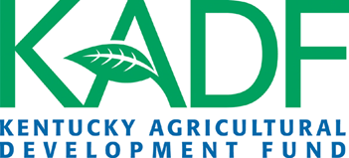
Applications are available for Carter County’s CAIP to assist farmers in making important
farm improvements.
Application Period:
October 6th, 2025-October 24th, 2025

No applications will be accepted before
Monday, October 6th, 2025, or after Friday, October 24th, 2025

Application Availability:
Carter Co. Conservation District
Monday – Friday (7:30 a.m. – 3:30 p.m.)

For More Information:
Contact Courtney Bond at (606) 474-5184 or email cartercoconservationdistrict@gmail.com

All applications are scored, based on the scoring criteria
set by the Kentucky Agricultural Development Board.
Administered by
Carter Co. Conservation District
526 East Main Street
Grayson, KY 41143
(606) 474-5184 Option 3
cartercoconservationdistrict@gmail.com
Eligible Incentive Areas:
Agricultural Diversification
AgTech & Leadership Development
Large Animal - Small Animal
Farm Infrastructure
Fencing & On-Farm Water
Forage & Grain Improvement
Innovative Ag. Systems
On-Farm Energy
Poultry & Other Fowl
Value Added & Marketing

